A+ Computer Science IFS – Final Project, by: Evan Dominguez Lab Value - 100

Lab Goal: This lab was designed to be hard and utilize all of the concepts that we have learned over our Jeroo unit. You will need to be able to navigate, turn, and continue throughout the maze without the Jeroo going in water or in a net. You must be able to utilize if and while statements, as well as multiple methods. You must be able to adapt your code based on what direction the Jeroo is heading in the maze.
Lab Description: This lab requires that you everything we’ve learned. You will need to use a looping statement to allow the Jeroo to constantly be moving forward through the maze, but also constantly checking if it is safe to turn, move forward, or if it should stop moving all together. You must get the Jeroo to the end of the maze, pick the flower to the left next to the water, turn around, and go back to the beginning.
Files Needed:
ChaoticMaze.jsc
ChaoticMaze.jev

Starting Screen:
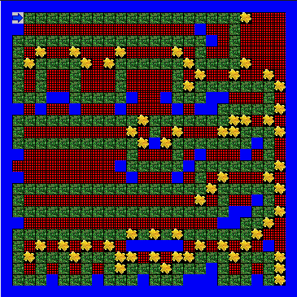
algorithm help

Preconditions
- Am I going in the right direction?
- Is it clear to move ahead?
- What type of block is ahead of me?
- When do I need to stop?
- When do I need to start again?

Postcondition
- Getting through the maze and back
- The flower at the very end of the maze on the left has been picked
- Jeroo is not in the water
- Jeroo is facing West
- Jeroo stops facing the water
- Jeroo didn’t cheat (No going through flowers as a shortcut!!!)

Ending Screen:
